**Module 5 - Basic HTML Website Assignment - Model Answer**

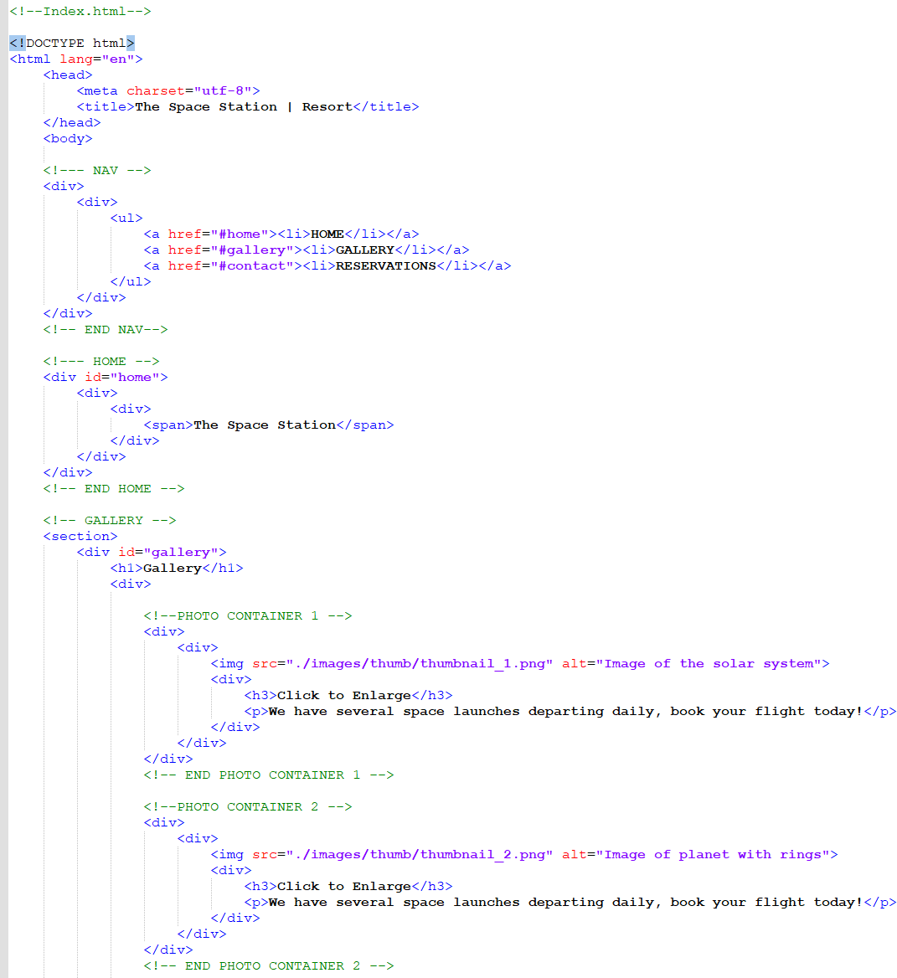

**<!——PKOTO CONTAINER** 3 ——>

<div>

<div>

<img src="./images/thumb/thumbnail 3.png" alt="Image of the galaxy">

<div>

‹h3›cli«k to e» *<*

<p>We have several spaoe launches departing daily, book your flight today!</p>

</div>

</div>

<fdiv>

<!-- END PHOTO CONTAINER 3 -->

<!--PKOTO CONTAINER 4 -->

<div>

<div>

<img src="./images/thumb/thumbnail_4.png" alt="Image of space war">

<div>

< 3>cli to *enlarge<fh3>*

<p>We have several spaoe launches departing daily, book your flight today!</p>

</div>

<fdiv>

<fdiv>

<!—— END **PHOTO CONTAINER 4 ——>**

<!——PKOTO CONTAINER 5 ——>

<div>

<div>

<img src="./images/thumb/thumbnail_5.png" alt="Image of planets">

<div>

<h3>Clink to En*la*rge:*<*

<p>We have several spaoe launches departing daily, book your flight today!</p>

</dive

</div>

<fdiv>

<!—— END **PHOTO CONTAINER 5 ——>**

**<!——PKOTO CONTAINER & ——>**

<div>

<div>

<img src="./images/thumb/thumbnail 6.png” alt="Image of planets and mountains">

<div>

‹h3>cli«k to e» *<*

<p>We have several spaoe launches departing daily, book your flight today!</p>

</div>

<fdiv>

# <fdiv>

**<!-- END PHOTO CONTAINER 6 -->**

<!--PKOTO CONTAINER 7 -->

<div>

<div>

<img src="./images/thumb/thumbnail_7.png" alt="Another space war image">

<div>

< 3>cli to *enlarge<fh3>*

<p>We have several spaoe launches departing daily, book your flight today!</p>

</div>

</div>

<fdiv>

<!-- END **PHOTO CONTAINER** 7 -->



## <div>

<div>

<img src="./images/thumb/thumbnail 8.png" a*t="Image o[ planet and sun">

## Cdiv>

<h3>Click to Enlarges/h3>

# <p>We have several space launches departing daily, book your flight today!</p>

## </dive

</dive C/dive

<div>

<div>

Cimg **src="./images/thumb/thumbnail 9.png" a*t="Image of Earth rising">**

<div>

**Ch3>Click to Enlarges/h3>**

<p>We **have several space launches departing daily, book your flight** today!</p>

## </div>

</dive

</div>



</dive

</div>

</sections

<!—— ENE GALLERY ——>

<!-- R?/P -->

<section>

<div **ic="contact">**

## <div>

**<h1>Reservations</h1>**

Cdiv>

<h2><span>Your **adventure is just Cbr/>Reserve your flight today!**

the moon.</span>

Please provide us with your basic contact information.

## <div>

<form action="" methoc="post">

<input **c*ass="rsvp" ty.e="text"** va*ue="">

<input c*ass="rsvp" ty.e="text" va*ue="">

<input **c*ass="rsvp" ty.e="text"** va*ue=""> Cinput **c*ass="rsvp" ty.e="text"** va*ue="'>

<div c*ass="[orm-spacer">

# <label c*ass="terms”>Terms and ConditionsC/label>

## </div>

<div>

<input **ty.e="submit" va*ue="Submit">**

</div> C/forme

</div>

</div>

</div>

</div> C/section>

<!-- RSVP -->

c!-- FCCTER -->

## <div ic="[ooter">

[**~~www~~.thespacestation.space**](http://www.thespacestation.space/) inbsp; anbsp; icopy; **2018**

## </div>

<!—— ENE FGGTER ——>

## </bodys

</html>